**Cottons Centre, Cottons Ln, London SE1 2QG**

**2014**

**Characteristic of Agile SCRUM**

**A brief overview**

**Tochi Ihenacho**

**FDM GROUP**

1. **Executive Summary**

This report highlights the characteristics of an Agile methodology as recommended by management for the purpose of informing and persuading the audience to adopt such a methodology. The article concludes by highlighting the notion that the main advantages of implementing a SCRUM framework; the chosen Agile development model, far outweigh the pitfalls. Hence, a recommendation for the “SCRUM” framework is justified due to the business value which its dynamic nature brings forth.

1. **Introduction**

A software development methodology can be described as a framework for structuring, scheduling tasks and overall maintaining control throughout the software development process of an information system (1).

Agile refers to a collection of software development methods which share a common requirement in seeking the client’s direct involvement when providing solutions (2). Thus, encouraging collaboration from initial stages; resulting in early delivery and continuous improvement.

The late 1980s and onwards saw an onslaught of negative stigma enforced on the majority of software development processes as they became infamous for operating a slow overly-regimented bureaucratic system(3). The business need for a more refined way of defining and detailing requirements gave birth to the Agile philosophy. A handful of thought-leaders in the industry embraced this innovation and reaped the benefits of accommodating this more successful development strategy which called for the design of a comprehensive structure superior to its predecessors (Waterfall) in order to support changing requirements in a shorter time frame.

1. **Agile**

The term “Agile Software Development” did not emerge until February 2001, after a summit with influential thought leaders and representatives from SCRUM, DDSM, Adaptive Software development and others sympathetic to the idea of a reformed development model met to form the Agile Software Development Manifesto (see Appendix 1). The now popular manifesto outlines the main ways in which an agile methodology supersedes Waterfall. This report will continue with a focus on the ways in which the very characteristics of one particular Agile methodology known as “Agile SCRUM” encompasses all the values highlighted in the Agile software development manifesto.

**3.1 SCRUM**

SCRUM is named after the rugby strategy in which teams score a definitive goal as a result of the individuals working effectively as a cohesive unit(4). In project management, it is also one of the more popular frameworks for various reasons which this report shall highlight. However, SCRUM is not a defined process but an experiential guide to project management (5). The SCRUM team is a cross-functional group in that technical roles are not clearly defined but instead members of the team work collectively to complete a task or ‘sprint’(6).

SCRUM and other agile methodologies follow an iterative development model in that the framework relies on the breakdown of projects into smaller increments or more specifically; ‘iterations’. Like Agile Scrum, an iterative model usually requires software testing to be executed at the initial stages of the development life cycle (7). *Iterations are full development cycles which lead to the release of an executable product, these acts as a subset of the final product under development (8)*. In the case of SCRUM, the iterations are referred to as “Sprints”(9).

***“The goal is to give clients what they want, not just what they signed off on”*** *Sandeep Sawhney, CTO at Icreon.*

**3.2 Benefits**

**3.2.1 Individuals and interaction (over processes and tools)**

SCRUM allows for a steady line of communication to be formed between then IT department and the clients as teams are designed to work effectively and interact frequently (9). These parameters all allow for backlogs to be dealt with quickly and efficiently, saving the client time and costs. Scrum is said to be self-reliant as each team member has the option to select them.

**3.2.2. Working Software (over comprehensive documentation)**

Daily SCRUM meetings allow members to identify progress as well as make future plans and more importantly eliminate any barriers to progress (10). Waterfall software development methodologies were criticised for the emphasis on providing comprehensive documentation on handling tasks but ultimately showed a slow reaction to dealing with development issues (11). Other measures include Sprint review meetings which are held at the end of each Sprint. Also, ‘Sprint Retrospective’ identifies areas of improvement for the next sprint. A strong line of communication is also beneficial in ensuring the development process is never halted as the‘Scrum shields the team form external influence and successfully mobilises the team (12).

**3.2.3. Customer collaboration (over contract negotiation)**

Another benefit of utilising the SCRUM framework is the fact that there is a representative of the client within the scrum team; known as, the Product Owner. The main responsibility of the Product Owner is to define product features as well as to notify the team of the products which the client needs to take priority (13).

Hence, SCRUM improves the probability of the project’s outcome satisfying the customer’s needs and adds business value by ultimately mitigating the risk of not delivering on the client’s expectations (13).

**3.2.4. Responding to change (Over following a plan)**

As customer requirements may change frequently throughout the course of the project; consultants who adopt an Agile methodology must also adapt to a highly responsive nature (3). SCRUM is deemed particularly responsive as it entails an inspection and adaption of the project after every ‘sprint’ (3). This gives the scrum master the opportunity to adapt to change in order to fulfil any client requests in a timely manner (5).

**4.0.** **Limitations**

A fundamental pitfall of SCRUM is the fact that this framework does not support the entire development life cycle. As a result, organisations tend to hybridise Agile Scrum with additional processes; for example, organisations often add additional process guidance of requirement gathering at initial development stages (12). Also, the autonomy which Scrum teams have may work to their detriment as major decision-making is left to the team. Hence, this method requires managerial scrutiny from the Scrum master (Project Manager) to be fully effective.

**5.0. Conclusion and recommendations**

In sum, Agile Scrum may not be as comprehensive as waterfall methodologies yet what it lacks in comprehension it definitely compensates for in other ways; such as, improved communication between teams which leads to a maximisation of efficiency as a result of a collective effort and consequently a minimisation of costs.

The author recommends the adoption of an agile-ish Scrum methodology; which is identical to Agile Scrum in many ways but alleviates its pitfalls by providing a pre-development phase which involves an intensive specification process; outlining user stories and more.

1. **Appendix**

**The Agile manifesto**

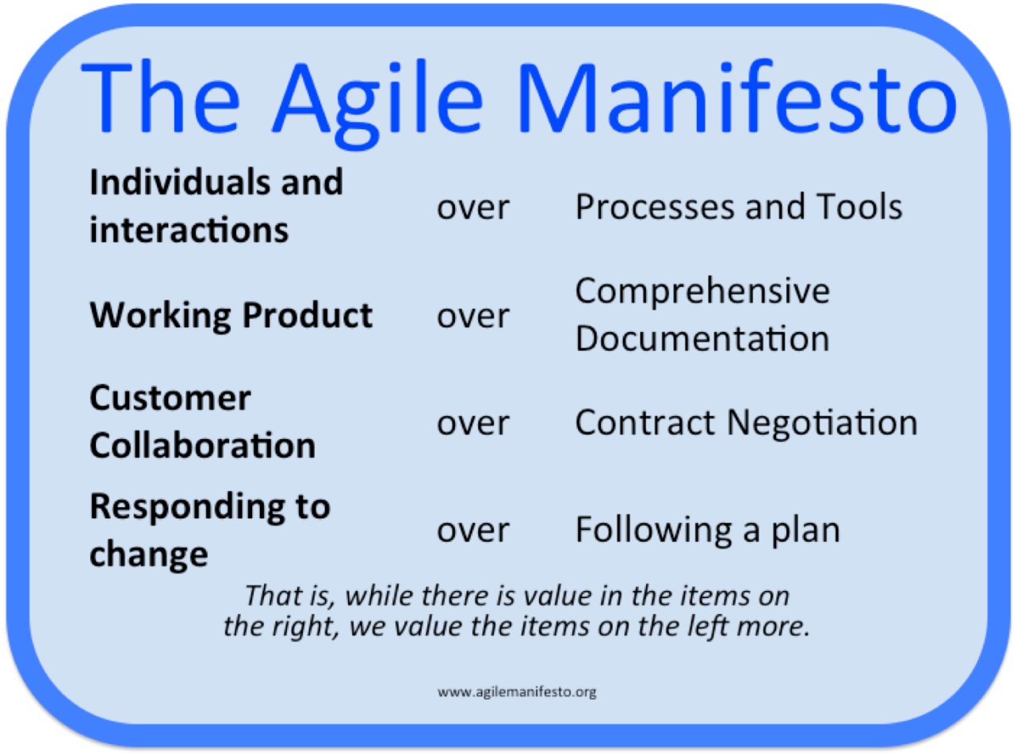

**Source: agilemanifesto.org**

**The Scrum process**

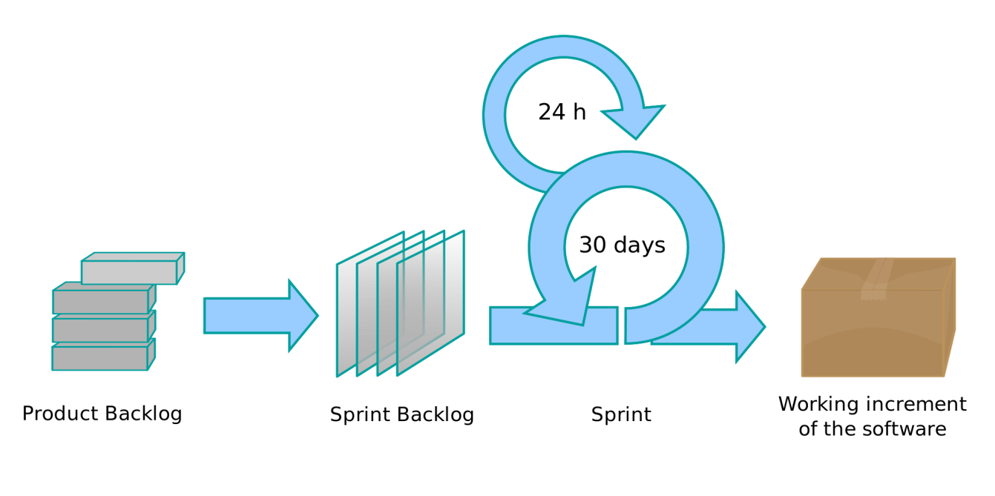

**Source: Kent et al (2001)**

**7.0** **Bibliography**

(1) Higgins, Tony (March 31, 2009). "Authoring Requirements in an Agile World". BA Times

(2) Venkatesh Krishnamurthy. (October 2012). A Brief History of Scrum: A Confusing Origin Story. Available: http://www.techwell.com/2012/10/brief-history-scrum . Last accessed 22 Nov 2014.

(3) Misty Faucheaux. (2012). *Scrum Methodology: Coordinating Teams to Produce Quality Products.* Available: http://www.brighthubpm.com/agile/2042-scrum-methodology-coordinating-teams-to-produce-quality-products/. Last accessed 22 Nov 2014.

(4) Takeuchi, Hirotaka; Nonaka, Ikujiro (January–February 1986). "The New Product Development Game" (PDF).*Harvard Business Review*. Last accessed 22 Nov 2014

(5) [Sutherland, Jeff](http://en.wikipedia.org/wiki/Jeff_Sutherland) (October 2004). "Agile Development: Lessons learned from the first Scrum" (PDF). Last accessed 22 Nov 2014

(6) Schwaber, Ken; Beedle, Mike (2002). Agile software development with Scrum. Prentice Hall. ISBN 0-13-067634-9.

(7) Schwaber, Ken (February 1, 2004). Agile Project Management with Scrum. Microsoft Press. ISBN 978-0-7356-1993-7.

(8) Cho, L (2009). "Adopting an Agile Culture A User Experience Team's Journey". Agile Conference: 416. doi:10.1109/AGILE.2009.76. ISBN 978-0-7695-3768-9.

(9) Gauthier,A (2011). "What is scrum". Planbox.

(10) Schwaber K, Sutherland J. "The Scrum Guide". Scrum.org. Last accessed 22 Nov 2014

(11) Pichler, Roman. Agile product management with Scrum : creating products that customers love (2010). Upper Saddle River, NJ: Addison-Wesley.

(12) Cohn, Mike. Succeeding with agile : software development using Scrum. Upper Saddle River, NJ: Addison-Wesley, 2010.

(13) Deemer P, Benefield G, Larman C, Vodde B (December 2012). "The Scrum Primer: A Lightweight Guide to the Theory and Practice of Scrum (Version 2.0)". InfoQ. Last accessed 22 Nov 2014

(14) Beck, Kent; et al. (2001). "Manifesto for Agile Software Development". Agile Alliance. Last accessed 22 Nov 2014